**PROPOSAL**

**Construction of training building**

**Introduction**

Our trust is meant for giving training programs. So that the building of training building is very important and very need of the trust. We have planned to have a lot of training for the students, women, youths, unemployed people and disabled. These trainings are come under three departments. They are Rehabilitation, Education and Healthcare.

**Our trainings**

**Below is our future plan to give intensifying training to the people.**

REHABILITATION DEPARTMENT:

For Self Help Groups (SHGs)

* Self employment training
* Making Poultry form
* Pickle making training
* Candle making training
* Nature mosquito coil making training
* Mushroom planting training
* Wire bag making
* Tailoring
* signature course

For youths:

* self employment training
* Typewriting course
* Employment exam preparation
* Tailoring
* Computer course
* Tally course
* Soft skill training
* Interview attending course
* Note making course (to become reporter)
* Cultural training

For Disabled:

* Chalk making
* Envelope making
* Wire bag making
* Tailoring
* Fancy items making

EDUCATION DEPARTMENT:

For students:

* Reading skill
* Writing skill
* Talent competitions
* Cultural training
* Educational special camps
* Summer camps
* Environmental courses

For youths

* IAS exam preparation training
* Government employment exam preparation training
* Environmental seminar
* Data entry job training

For women

* Awareness programs to continue study

HEALTH CARE DEPARTMENT:

For women

* Anemia preventing programs
* Health worker training with job

For youths

* Give motivation to study MBBS
* First aid training

These trainings are planned to give for the people. After the training they can get the job and settle them in their life. If the problem is the economic we can provide the employment loan from the banks, TAHDCO and from the district co-operative societies. So that trainings are to be valid and to be helpful for the people.

Successes trainings:

Already we have done three trainings (pickle making, poultry farm and Pongal sports day) and credit linkages with the bank for the self help groups and students in the rented building. The rent was too high and the accommodation and the allowed participation were low. If the accommodation is good the more participants might have trained through us.

POULTRY FORM

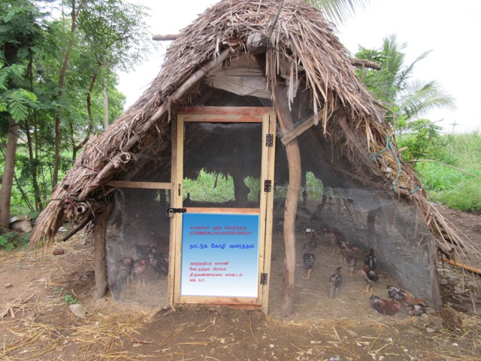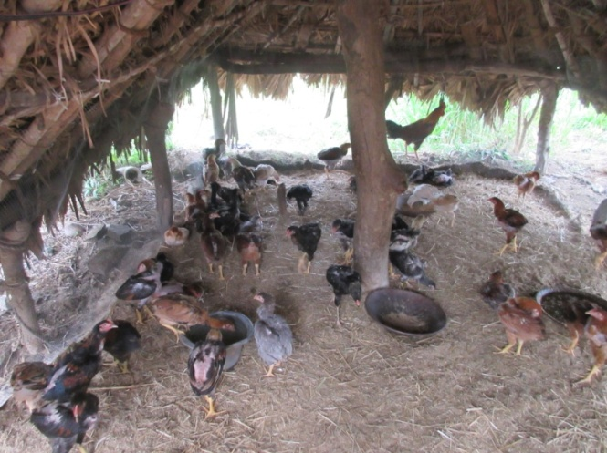

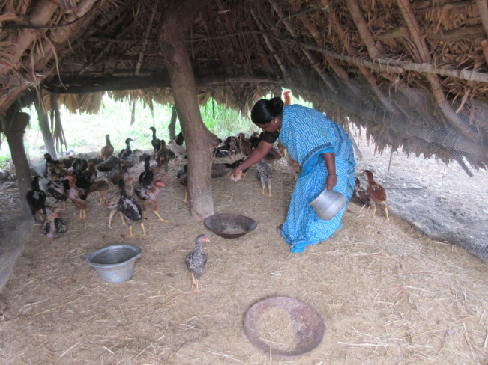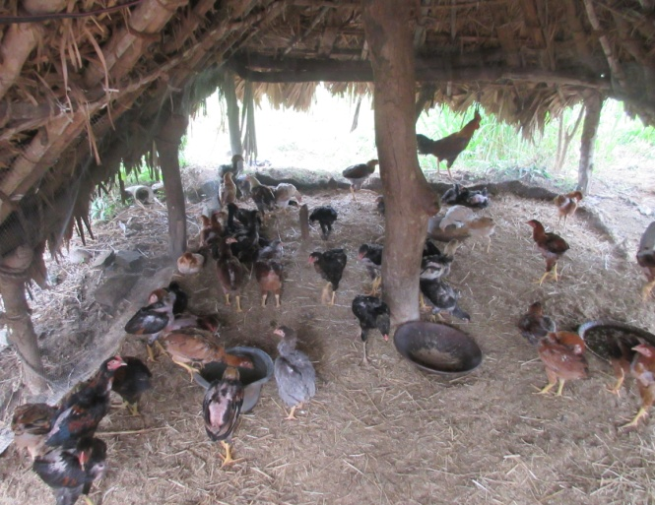

PICKLE MAKING TRAINING

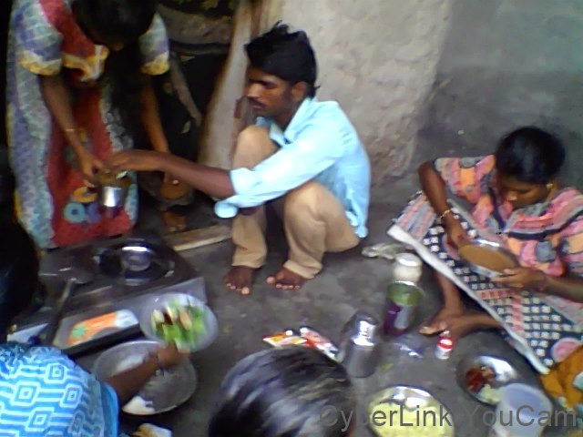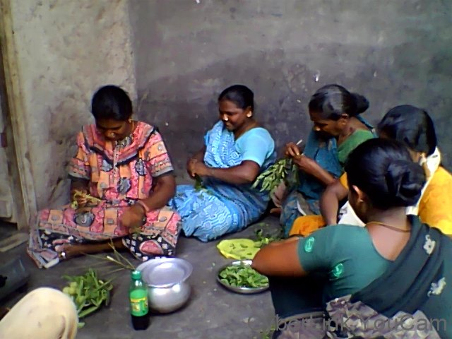

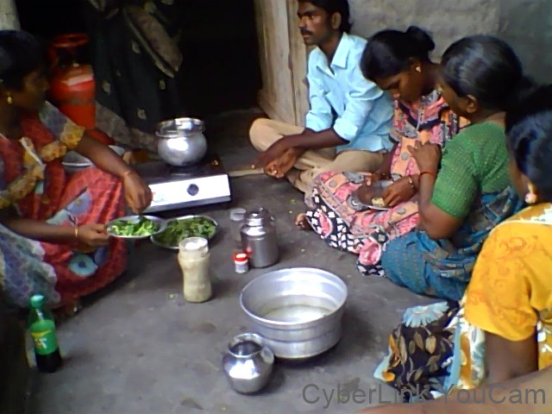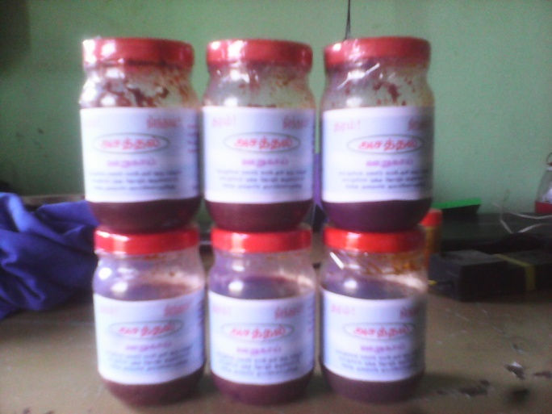

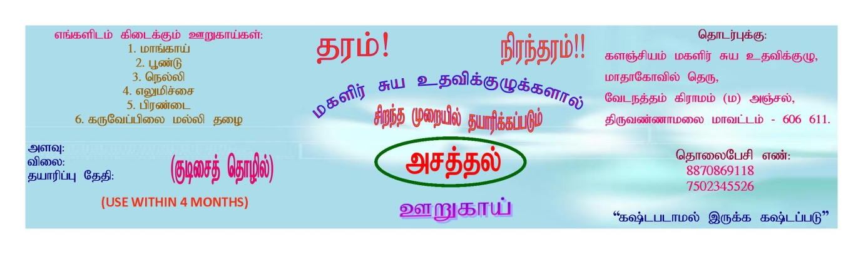

**Purpose of the building**

The above said trainings will be conducted in our training building. That is the main purpose of the proposal. If we have training in the rent building that may not be suitable for our training and expenses also too high. If we have the own training building, we could give trainings even in the low budget and the situation also fit for us. That is our main purpose of the building.

**Rooms list**

**Admin and training block**

1. **Office room**
2. **Store room**
3. **library**
4. **program director office**
5. **Training hall 1**
6. **Training hall 2**
7. **Training hall 3**
8. **Tailoring hall (school bag)**
9. **Rest rooms**
10. **Electrical rooms**
11. **Guest rooms**
12. **Materials store room**

**Hostel campus**

1. **Office room**
2. **Students staying rooms**
3. **kitchen with dining hall**
4. **Rest rooms**
5. **Play ground**
6. **store room**

**Building plan**

**Kitchen with dining hall**

HOSTEL BUILDING

LIBRARY, ELECTRICAL & STORE ROOM

GUEST ROOMS

**Training hall 1**

**Tailoring hall**

REST ROOMS



**Training hall 2**

**Training hall3**

PROGRAM DIRECTOR OFFICE

ADMINISTRATION

OFFICE ROOM

PARKING AREA

**Estimated Budget**

|  |  |  |  |
| --- | --- | --- | --- |
| **S.NO** | **CONTENT** | **QUANTITY** | **AMOUNT (INR)** |
| **1** | **Land Purchase** | **1acres*15000** | **1500000** |
| **2** | **CONSTRUCTION** | **18*15000** | **2700000** |
| **2** | **PAINTING & ELECTRICAL** | **18*50000** | **900000** |
| **3** | **WAGES** |  | **1000000** |
|  | **Total** |  | **6100000** |
| **$ 91890.40 US DOLLER** | | | |

**Conclusion:**

After construction of the training building, it will be used for the poor the vulnerable community (Dalits) women and children will trained a lot and grow them and with their good dignity. We can strengthen the hands and the confidence of students, youths, women, disabled and unemployed men. Please help us to do this wonderful service to the people. We are the small but we planned big because of the service to the vulnerable is fulfilled in the manner of the good economic and social development.

Please visit the page: www.artcentre.yolasite.com

**Thank you**